|  |  |
| --- | --- |
|  | 1. Show company name and the name of items it provides. 2. Show all the item names with the company name whether any company provides them or not. 3. Show all the company names with the item names whether it provides any item or not. 4. Show all the company names along with all the item names they provide. Show companies regardless they provide any item or not and Vice Versa. |

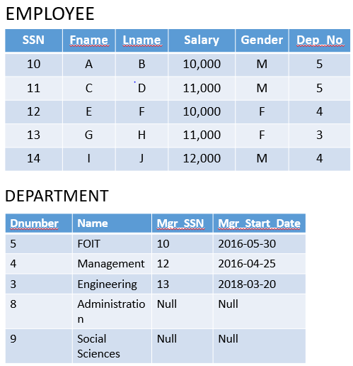

1. Show employee names with the department names they manage.
2. Show all employee names with the department names they manage whether they manage any department or not.
3. Show all department names with the employee names who manage them whether they are managed by any or not.
4. Show all employee names with department names they manage. Also result should have all department names whether they are managed by any employee or not.

Here is sample data of a company. Which join will you use to retrieve the following information.

* Show name of all salesman with name of their customer whether they have served to any customer or not.
* Show details of all Customers with the name of salesmen whether they have purchased anything from salesman or not.
* Show name of all salesman along with their customers’ name.
* Show name of all salesmen with the name of their costumers’ name whether customers have purchased anything from salesman or not and vice versa.